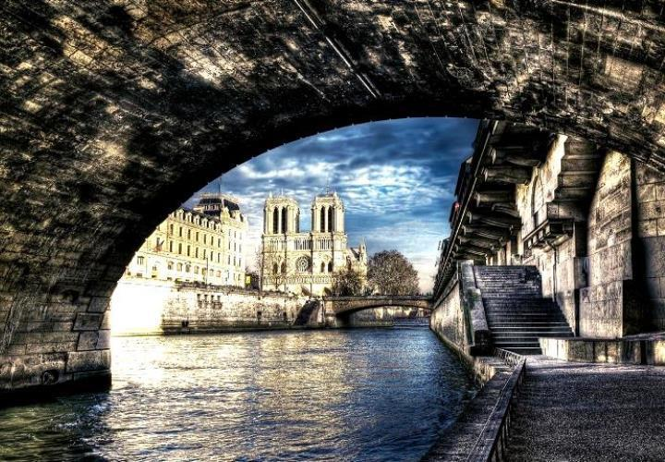

|  |  |
| --- | --- |
| Distinguished guests: | Mrs Donna Foulger |
| Agency: | Novus Travel - Arlington (HQ) |
| Agent: | David Cassel |
|  | |
| **Duration:** | **5day / 4nights** |
| **Number of Persons:** | **1** |
|  | |
| Summary | |
| Welcome to France! | Page 4 |
| Your Itinenary | Page 6 |
| Paris | Page 9 |
| Detailed itinerary | Page 43 |
| Sales and terms conditions | Page 44 |

**Welcome to France!**

|  |  |
| --- | --- |
|  | France is as diverse as its landscapes: from the endless beaches of Normandy to the perched villages of Provence and the green hills of Auvergne to the turquoise bays of Corsica. Meet the real French for wine tastings and cooking classes, off-the-beaten-tracks visits, exclusive itineraries with our expert licensed guides that drive and more...  Discover the largest country of West Europe, more of half of France is composed of vast plains, beautiful coasts and France hosts Western Europe's highest peak in the Alps, Mont Blanc. The climate is temperate, except near the mountains or in the northeast, with cool winters and mild summers. Southern France is generally warm, with mild winters and hot summers.  French people are known for good fashion sense and good food. They are courteous people, but also frank and usually to the point. French is the official language of France, and it is important for you to learn a bit of French. Indeed, your trip will be more enjoyable if you are able to relate to French people. Also, it will be easier to understand the culture once you learn the language.  As for French manners, the handshake is commonly used in France when people meet another for the first time, in both social and business settings. Close friends greet each other by kissing each other on the cheek (Ia bise). People typically greet one another with bonjour (good morning), bonsoir (good afternoon) and au revoir (goodbye). Party guests are expected to bring a gift, such as flowers or a bottle of wine. |

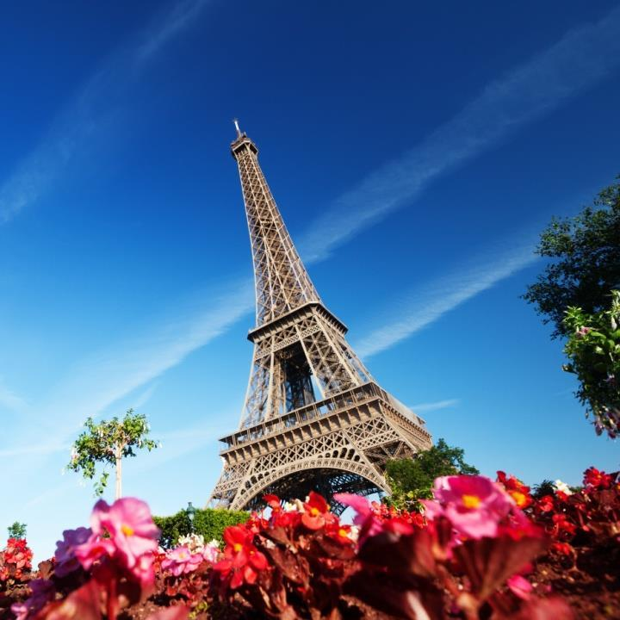

|  |  |  |  |  |  |  |  |  |  |  |  |  |  |  |  |
| --- | --- | --- | --- | --- | --- | --- | --- | --- | --- | --- | --- | --- | --- | --- | --- |
| **Your Itinenary**   |  |  | | --- | --- | | Apr 22: | Arrival in Paris | | Apr 22: | La Fontaine de Mars Pullman Paris Tour Eiffel**** | | Apr 23: | Full day excursion with a guide-driver in Paris Photos in Paris with a private photographer Musée du Louvre Ile de la Cité Le Marais Pullman Paris Tour Eiffel**** | | Apr 24: | Pullman Paris Tour Eiffel**** | | Apr 25: | Full day excursion with a guide-driver in Paris Musée d'Orsay Jardins du Trocadéro Jardin du Luxembourg Montmartre Pullman Paris Tour Eiffel**** | | Apr 26: | Pullman Paris Tour Eiffel**** | | Apr 26: | Departure Day | |  |

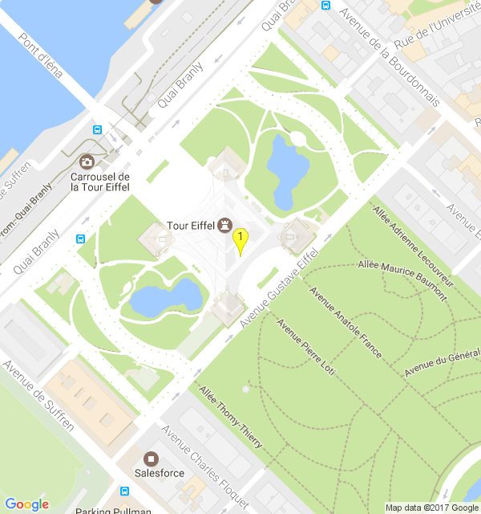

|  |
| --- |
|  |

|  |
| --- |
| **Paris** |

**Discover Paris!**

|  |  |
| --- | --- |
|  | Like all the world's great capitals, Paris lives at a fast pace, by day and night. It is divided into 20 districts that spiral out like a snail shell from the first, centered round the Louvre. Enjoy a stroll through Paris while on vacation and soak up the "art de vivre", it will feel as if you are walking through an open-air museum. Admire the city's regal buildings, gardens, fountains and places which have witnessed so monumental events & so fascinating history.  Paris is a place of iconic architecture, with its famous cloud-piercing Eiffel tower, Arc de Triomphe at the end of the most famous avenue of the world, les Champs-Elysees. Notre-Dame and its gargoyles, old bridges and Art Nouveau cafes are famously part of the City. Always evolving, the City now proudly shows the contemporary Centre Pompidou and the Musee du Quai Branly and its vegetal wall.  Paris is also famous for its cuisine. Anywhere from cosy bistros to three-star Michelin stars, you'll be able to find quality produces, with excellent presentation and preparation, always served with wine. Stop at the cheese shops, boulangeries, patisseries for top produces to take to a picnic in the city's parks and gardens.  Lastly, browse designer boutiques, flagship haute couture stores, concept stores to find the perfect dress. Wander in vintage shops and flea markets, original bookshops and bookseller on the banks of the Seine, antique dealers, gourmet food and wine shops galore! |

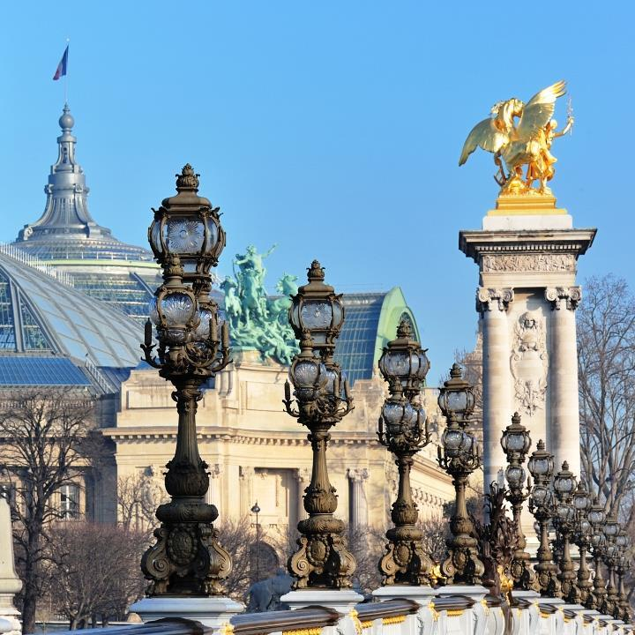

**APR 22, 2017 - YOUR DINNER SUGGESTION IN PARIS**

**La Fontaine de Mars**

|  |  |
| --- | --- |
|  | Very typical Parisian brasserie in the decor and ambiance typical French dishes such as Foie Gras and Duck Confit. Nice Patio during sunny days.  La Fontaine de Mars is one of the oldest traditional brasseries in Paris and since 1908, it has welcomed both amateurs and connoisseurs of French southwestern cuisine. 3 families have run the restaurant since its creation. Today, the Boudon family has kept the authentic charm of this old brasserie and its exceptional cuisine: duck comfit, magret and foie gras. Open 7 days a week except on December 28th and January 1st, this charming venue can now boast to have a lot of regular |

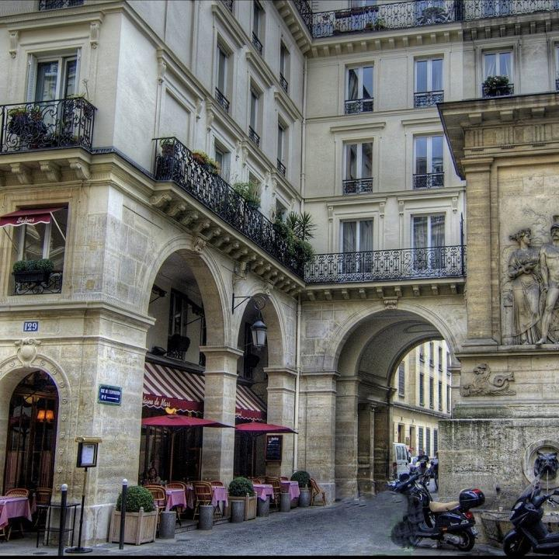

**APR 22 - 27, 2017 - 4 NIGHTS - YOUR HOTEL IN PARIS**

**Pullman Paris Tour Eiffel\*\*\*\***

|  |  |
| --- | --- |
|  | A 4-minute walk from the Eiffel Tower, this sleek hotel in the Left Bank is 5 minutes' walk from the Gare du Champ de Mars railway station and 6 minutes' walk from the Bir-Hakeim metro stop.  Chic, polished rooms and suites feature flat-screen TVs, designer toiletries and free WiFi. Upgraded rooms add rainfall showerheads, Nespresso machines, private balconies and/or Eiffel Tower views. Suites offer work space and/or living areas.  There's a stylish restaurant serving international fare. Other amenities include an exercise room and a business center. |

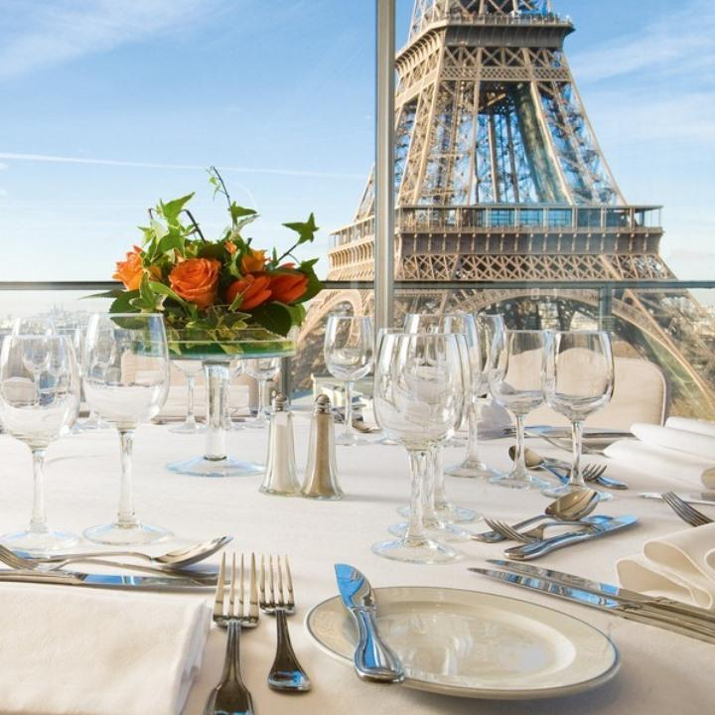

**APR 23, 2017 - YOUR MORNING EXPERIENCE IN PARIS**

**Photos in Paris with a private photographer**

|  |  |
| --- | --- |
|  | Elope in the streets of Paris with your own private photographer.  Go around the most famous views of Paris with your private photographer to shoot romantic photos with a taste of France.  Make one with the streets of Paris in a splendid glamorous photoshoot. |

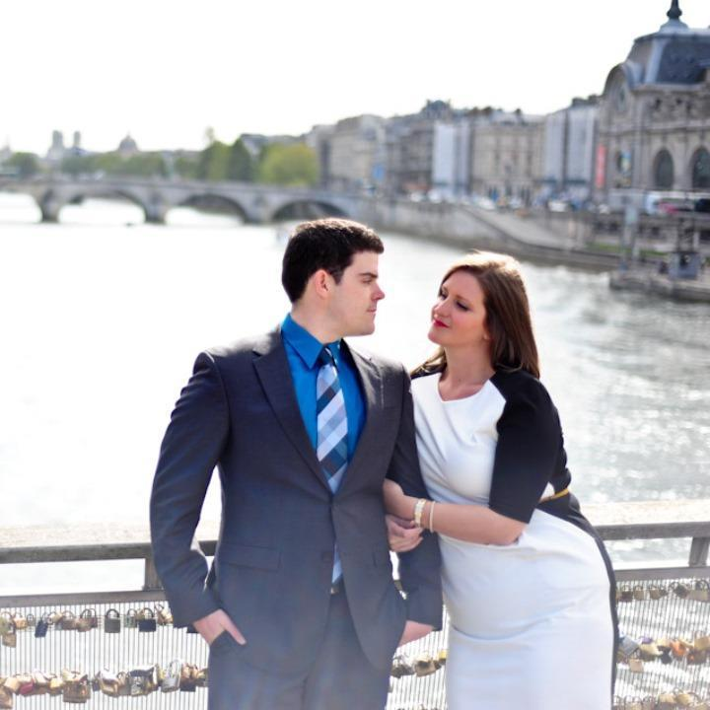

**APR 23, 2017 - YOUR FIRST HIGHLIGHT IN PARIS**

**Musée du Louvre**

|  |  |
| --- | --- |
|  | The Louvre museum exemplifies traditional French architecture since the Renaissance, and it houses a magnificent collection of ancient and Western art.  Walking through the Louvre Museum is like walking through the history of France and into the minds of kings and revolutionaries. The reigns of Louis XIII and Louis XIV saw major expansion and a linking of the palaces and halls, which make up the museum today.  Divided into seven sections, the Louvre collections incorporate works dating from the birth of the great antique civilisations right up to the first half of the 19th century, thereby confirming its encyclopaedic vocation.  The present Louvre departments include Oriental (ancient Mesopotamian) antiquities; Egyptian antiquities; Greek and Roman antiquities; sculpture from the Middle Ages to modern times; furniture and objets d'art; and paintings representing all the European schools. A section of the museum is devoted to Islamic art.  Among the thousands of priceless paintings is Leonardo Da Vinci's “Mona Lisa”, probably the most famous painting in the world, housed in the Salle des Etats in a climate-controlled environment behind protective glass.  Works of artists like Fragonard, Rembrandt, Rubens, Titian, Poussin, and David can also be seen. One of the most famous sculptures in the collection is the “Venus de Milo”.  The Musée du Louvre is unquestionably one of the finest museums in the world. |

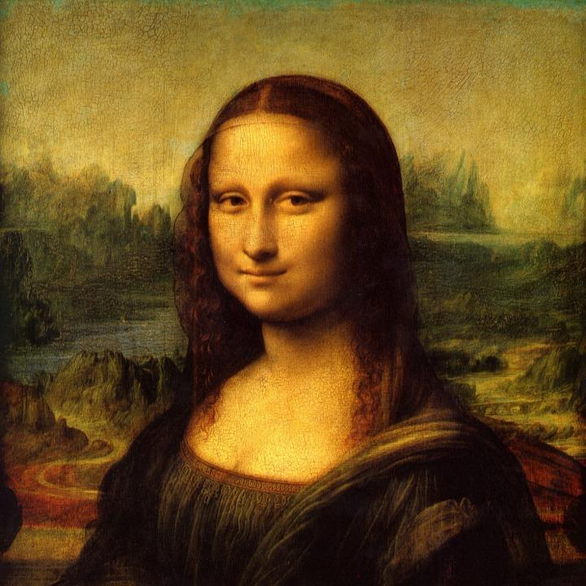

**APR 23, 2017 - YOUR SECOND HIGHLIGHT IN PARIS**

**Ile de la Cité**

|  |  |
| --- | --- |
|  | Ile de la Cité, once known as Lutetia, is the oldest settlement in Paris, and boasts more than its fair share of Paris sights: the Pont Neuf, the Pont de l’Archevêché and Notre Dame cathedral, to name only three. Its location bang in the middle of Paris, with Châtelet to the north and Saint-Germain-des-Prés to the south, makes it the central crossroads of the city, which grew outwards from here. When you’ve finished visiting all the sights, take one last admiring look at the magnificent facade of Notre Dame, then stroll along the banks of the Seine and stop to watch improvised concerts by wandering musicians, for whom this area is a prime performance venue.  Ile de la Cité is also the perfect place for a riverside picnic. At night, the bridges are beautifully lit, and there is a feeling of midsummer magic. |

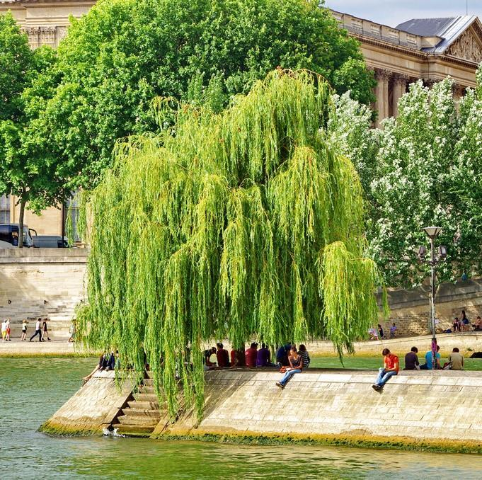

**APR 23, 2017 - YOUR SECOND HIGHLIGHT IN PARIS**

**Notre Dame de Paris**

|  |  |
| --- | --- |
|  | Notre Dame de Paris is a Gothic cathedral on the eastern half of the Île de la Cité and widely considered to be one of the finest examples of French Gothic architecture, known simply as Notre Dame in English. It is a Gothic cathedral on the eastern half of the Île de la Cité in Paris with its main entrance to the west. It is still used as a Roman Catholic cathedral and is the seat of the Archbishop of Paris. Notre Dame de Paris is widely considered one of the finest examples of French Gothic architecture. It was restored and saved from destruction by Viollet-le-Duc, one of France's most famous architects. Notre Dame translates as "Our Lady" from French.  At the end of the 18th century, during the French Revolution, many of the treasures of the cathedral were either destroyed or plundered. The statues of biblical kings of Judea (erroneously thought to be kings of France) were beheaded. Many of the heads were found during a 1977 excavation nearby and are on display at the Musée de Cluny. Only the great bells avoided being melted down, and the cathedral was dedicated first to the Cult of Reason, and to the Cult of the Supreme Being. The church interior was used as a warehouse for the storage of forage and food. |

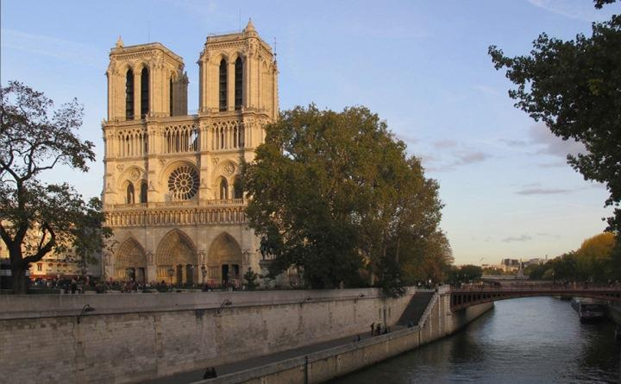

**APR 23, 2017 - YOUR SECOND HIGHLIGHT IN PARIS**

**Sainte-Chapelle**

|  |  |
| --- | --- |
|  | Visit the Sainte Chapelle, a masterpiece of Flamboyant Gothic architecture built by Saint Louis in the heart of the Palais de la Cité on the Ile de la Cité in Paris. Discover its unique stained glass windows rendering the air iridescent with light and colour, symbols of the Heavenly Jerusalem.La Sainte Chapelle is perhaps the high point of the full tide of the rayonnante period of Gothic architecture. From the Palais de Justice, passing through a vaulted passage, one can gain access to the Sainte Chapelle. It was commissioned by Louis IX the Saint for housing the relic of the Crown of Thorns purchased by the sovereign in Venice in 1239, having been previously brought here from Constantinople.  It is probable that this church was designed by the same architect who designed Saint-Germain-des-Prés, Pierre de Montreuil; in this case, though, the design was for two chapels, one on top of the other, which were consecrated in 1248. The lower chapel corresponds to a high level basement, above which open up large, pinnacle windows.  The steeply sloping roof is enriched with a marble balustrade: a soaring, honeycombed spire 75 metres high is the worthy topping to this graceful piece of architecture. |

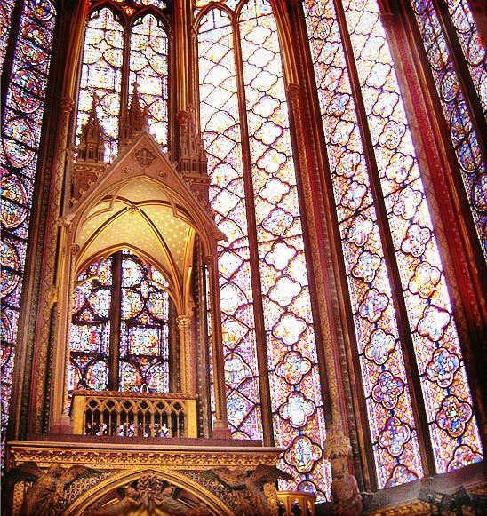

**APR 23, 2017 - YOUR SECOND HIGHLIGHT IN PARIS**

**Conciergerie**

|  |  |
| --- | --- |
|  | The Conciergerie looks every inch the forbidding medieval fortress. However, much of the façade was added in the 1850s, long after Marie-Antoinette, Danton and Robespierre had been imprisoned here. The 13th century Bonbec tower, built during the reign of St Louis, the 14th century twin towers, César and Argent, and the Tour de l'Horloge all survive from the Capetian palace.The visit takes you through the Salle des Gardes, the medieval kitchens with their four huge chimneys, and the Salle des Gens d'Armes, an impressive vaulted Gothic hall built between 1301 and 1315 for Philippe le Bel. After the royals moved to the Louvre, the fortress became a prison under the watch of the Concierge.  The wealthy had private cells with their own furniture, which they paid for; others crowded on beds of straw. A list of Revolutionary prisoners, including a hairdresser, shows that not all victims were nobles. In Marie-Antoinette s cell, the Chapelle des Girondins, are her crucifix, some portraits and a guillotine blade. |

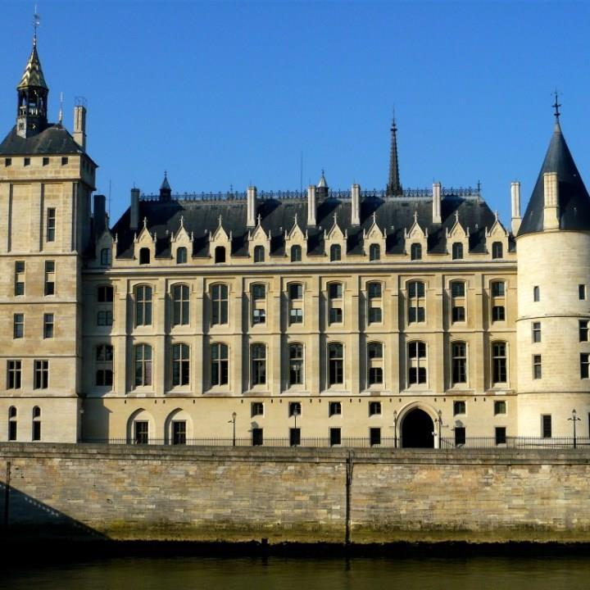

**APR 23, 2017 - YOUR THIRD HIGHLIGHT IN PARIS**

**Le Marais**

|  |  |
| --- | --- |
|  | The Marais, one of Paris’ oldest and most dazzling district. Le Marais (meaning “the marsh” in French) is a district in Paris, traditionally a bourgeois area, but also well-known historically. It spreads across parts of the 3rd and 4th arrondissements in Paris (on the Rive Droite, or Right Bank, of the Seine). First developed in the 12th century, the Marais was a royal favorite under Henri IV and Louis XIII and then fell to ruin after the Revolution in 1789. Since its revival in the 1960's, it has become one a center of artistic and cultural life. |

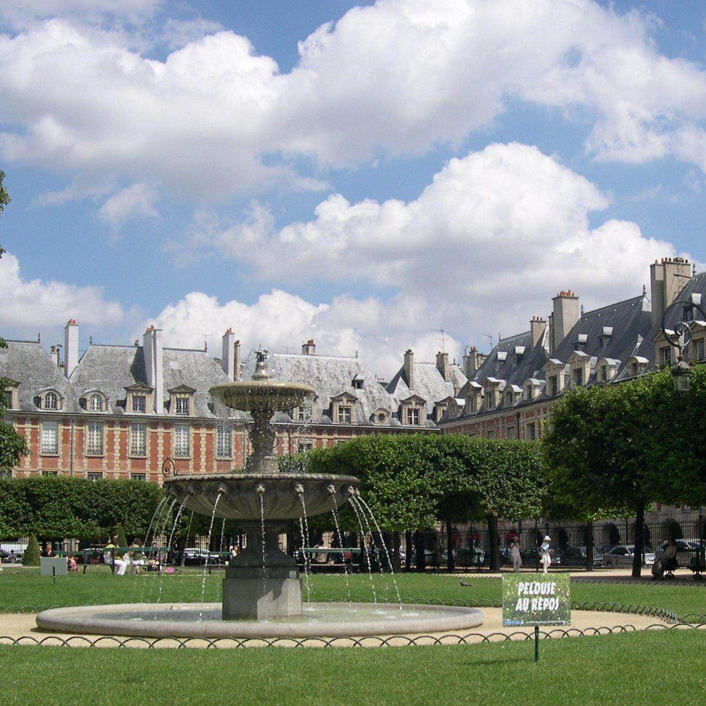

**APR 25, 2017 - YOUR FIRST HIGHLIGHT IN PARIS**

**Musée d'Orsay**

|  |  |
| --- | --- |
|  | There are many masterpieces at the Musée d'Orsay include work by Delacroix, Manet, Guaguin, Cézanne, Monet, Renoir, Sisley, van Gogh and many more great artists. Among the spectacular works on display at the Orsay Museum is Auguste Clésinger's Woman Bitten by a Snake which scandalised all of Paris in 1847 by supposedly depicting a woman not bitten by a snake but in the throes of passion and, said prominent critics of the time, modelled from real life on 19th Century socialite Apollonie Sabatier. Musée d'Orsay is one of the finest museums in Paris, both for the fantastic building itself and the treasures inside and is truly a wonder which no Paris visitor should miss! The Orsay Museum was originally designed as a train station in 1900. By the 1950's it became apparent that the platforms were too short for modern trains and the building became home to a theatre. In the 1970's it was remodelled and converted into a museum dedicated to displaying art from the period 1848 to 1915. The museum is built on 3 levels: on the ground floor, galleries are distributed on either side of the central nave, which is overlooked by the terraces of the median level, these in turn opening up into additional exhibition galleries. The top floor is installed above the lobby, which continues into the highest elevations of the former hotel, over the rue de la Légion d'Honneur. |

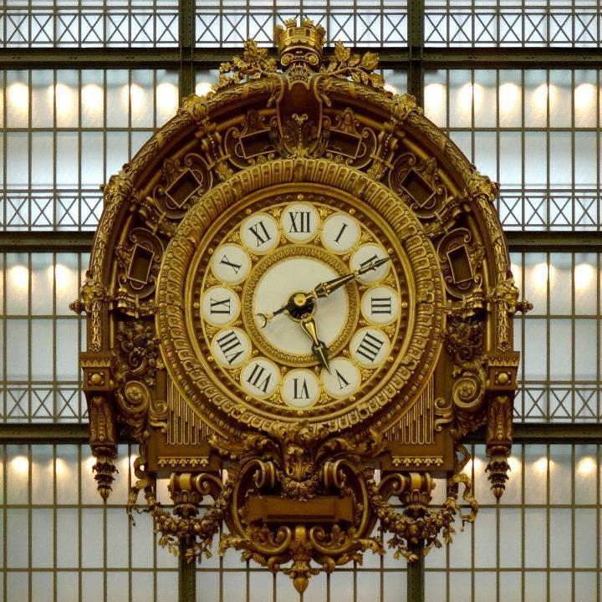

**APR 25, 2017 - YOUR SECOND HIGHLIGHT IN PARIS**

**Jardins du Trocadéro**

|  |  |
| --- | --- |
|  | If there is one garden you really must visit when you go to the Eiffel Tower, it’s the Trocadéro gardens. Created for the Universal Exposition in 1937, this green space of nearly 10,000 m² offers a stunning view of the Eiffel Tower dominating the capital (don’t forget your camera). The centrepiece of the gardens is the famous Warsaw fountains which, with its 20 water cannons, offers a remarkable water display, especially on summer evenings when the illuminations around the fountains add to the attraction. There are a number of sculptures to be admired, including gilded bronze animal statues, and the two stone statues, 'L'homme' by Pierre Traverse and 'La Femme' by Daniel Bacqué. |

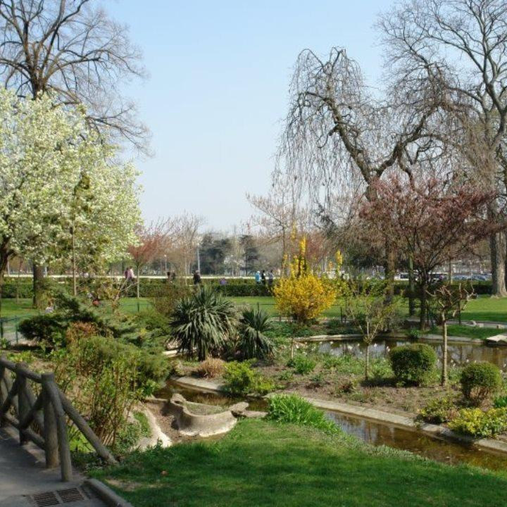

**APR 25, 2017 - YOUR THIRD HIGHLIGHT IN PARIS**

**Jardin du Luxembourg**

|  |  |
| --- | --- |
|  | Situated on the border between Saint-Germain-des-Prés and the Latin Quarter, the Luxembourg Gardens, inspired by the Boboli Gardens in Florence, were created upon the initiative of Queen Marie de Medici in 1612. The gardens, which cover 25 hectares of land, are split into French gardens and English gardens. Between the two, lies a geometric forest and a large pond.  There is also an orchard with a variety of old and forgotten apples, an apiary for you to learn about bee-keeping and greenhouses with a collection of breathtaking orchids and a rose garden. The garden has 106 statues spread throughout the park, the monumental Medici fountain, the Orangerie and the Pavillon Davioud. There are many activities and facilities for children such as puppets, rides and slides. Adults, whether they are Parisians or tourists, can play chess, tennis, and bridge or remote control boats. The cultural programme is characterized by free photography exhibitions on the garden railings and by concerts in the bandstand. |

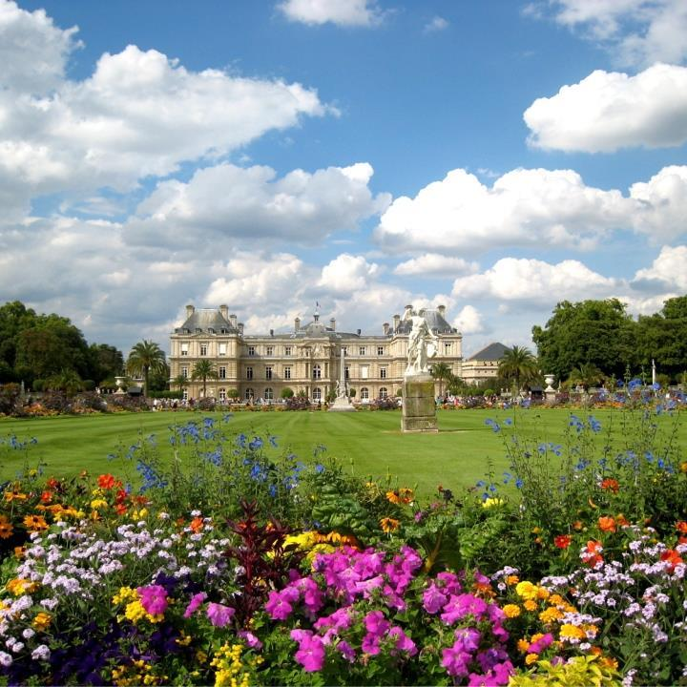

**APR 25, 2017 - YOUR FOURTH HIGHLIGHT IN PARIS**

**Montmartre**

|  |  |
| --- | --- |
|  | The Montmartre Hill is very famous for the Sacré-coeur Basilica and its fantastic panoramic view over Paris, but it is also a gastronomical and cultural area with an authentic charm.  Strewn with staircases and charming lamps, Montmartre is a meeting place for lovers of every era.  Discover Montmartre hill and its good addresses for restaurants, theaters and cabarets.  Forget the well-trodden path and open the door to another Montmartre, the last village of Paris, with its beautiful streets full of history, charm and happiness. |

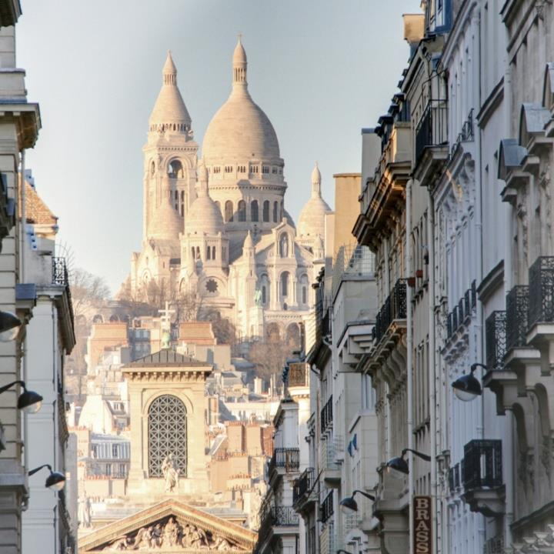

**APR 25, 2017 - YOUR FOURTH HIGHLIGHT IN PARIS**

**Basilica of Sacre-Coeur**

|  |  |
| --- | --- |
|  | The Sacré-Coeur, consecrated in 1919, is one of the most iconic monuments in Paris. At the top of the Butte Montmarte, it has one of the most beautiful panoramic views of the capital, from more than 400 metres above ground. In a Roman-Byzantine style, the Sacré Coeur is recognizable by its white colour. Inside the building, the ceiling is decorated with the largest mosaic in France measuring about 480 m². The crypt is also worth a visit. And to go even higher up, visitors can access the dome where the 360° view of Paris is magnificent. A short walk from the Sacré Coeur is the Place du Tertre, the district of Abbesses with its steep, winding roads, and at the bottom of the hill, the famous Moulin Rouge cabaret. |

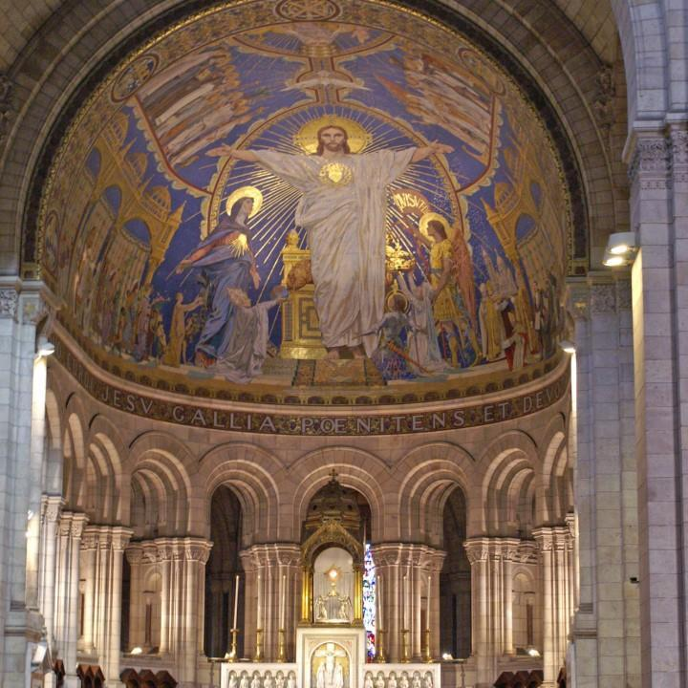

**APR 25, 2017 - YOUR FOURTH HIGHLIGHT IN PARIS**

**Place du Tertre**

|  |  |
| --- | --- |
|  | The Place du Tertre got its name from the fact that it is situated on top of a “tertre”, that is a small hill!  Famous all over the world for its painters, portraitists and terraces, the old town square of Montmartre welcomes thousands of tourists every day and is the perfect place for a stroll.  The place opened in 1635, and by the end of the 18th century till World War One, the whole Montmartre Boheme could been seen here:painters, songwriters and poets.  Today, a host of painters and on-the-spot portraitists welcomes visitors all year round. The “carré aux artistes” (artists’ square) is divided into 149 spaces, each 1m² large, which enables two painters to work in relay. |

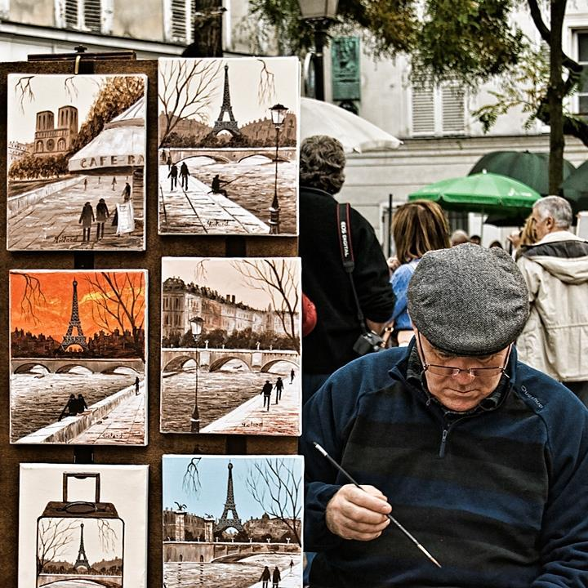

|  |
| --- |
|  |

|  |
| --- |
| **Services** |

|  |  |  |  |  |  |  |  |  |  |  |  |
| --- | --- | --- | --- | --- | --- | --- | --- | --- | --- | --- | --- |
| **Detailed itinerary**   |  | | --- | | **Apr 22** | | -Reservation at La Fontaine de Mars  Transportation and dinner not included, suggestion only.  - Accommodation: Pullman Paris Tour Eiffel****  Accommodation booked on | | **Apr 23** | | - Full day excursion with a guide-driver in Paris  10:00 am : pick up at your hotel in Paris  06:00 pm : drop off at your hotel in Paris  Your guide-driver's contact details: Christian - Tel: +33 (0)6 20 61 21 57  - Photos in Paris with a private photographer  From 10:00 am to 2:00 pm.  Entrance fees not included.  Your photograph's contact details: Thibault - Tel: +33 (0)6 20 47 86 11  - Musée du Louvre  Entrance fees included.  - Ile de la Cité  Entrance fees not included.  - Le Marais  Entrance fees not included.  - Accommodation: Pullman Paris Tour Eiffel****  Lunch and entrance fees not included. | | **Apr 24** | | - Accommodation: Pullman Paris Tour Eiffel**** | | **Apr 25** | | - Full day excursion with a guide-driver in Paris  10:00 am : pick up at your hotel in Paris  06:00 pm : drop off at your hotel in Paris  Your guide-driver's contact details: Christian - Tel: +33 (0)6 20 61 21 57  - Musée d'Orsay  Entrance fees included.  - Jardins du Trocadéro  - Jardin du Luxembourg  - Montmartre  - Accommodation: Pullman Paris Tour Eiffel**** | | **Apr 26** | | - Accommodation: Pullman Paris Tour Eiffel**** | |  |

|  |  |
| --- | --- |
|  | **Sales and terms conditions**  Please note that our quotes are merely informative as all services are subject to availability. All fares and availabilities will therefore be confirmed on the day you confirm your client’s booking by faxing us back the signed credit card authorization form.  The total NET price provided by Découvertes includes the services listed, a tailor-made itinerary, Découvertes’ fees and taxes. We consider that our negotiated rates are confidential and therefore, as a general rule, Découvertes does not provide a break-down of rates and services – thank you for your understanding.  - Personalised Itinerary  - Prepaid Voucher/s  - Co-ordination and Support  - 24 hours Concierge service (Assistance) during your trip  - Airfare not listed in the itinerary  - Transfers not specified in the itinerary  - Entrances fees when not mentioned  - Meals when not mentioned  - Room Service  - Excess Baggage Charges  - Porterage  - Passport and Visa Fees  - Personal & Travel Insurance  - Gratuities  - Any Item specified as ‘Own Arrangements |

|  |  |
| --- | --- |
|  | **Terms conditions**  Our Guide-drivers will chauffeur your clients; they are also licensed to guide and accompany them into museums and monuments.  Driver-guides are NOT qualified to enter and guide your clients into museums, as well as around historical monuments and sights, for this purpose we recommend your clients have either a driver AND a guide or a Guide who is licensed and insured to drive. Our Driver-guides all speak very good English and will chauffeur your clients on sightseeing tours, their knowledge of the historical aspects of the territory can NOT be incompared to that of a guide.  A 30% deposit is requested at the time of booking and full payment 45 days prior to your clients' arrival in France, unless otherwise advised. Payment is made in Euros and can be made by credit card, US Dollars check, Euro check or wire transfer.  Découvertes accepts the following credit cards: American Express, Visa and Mastercard. Please note that Découvertes does not charge any supplement for credit card payments.  You will receive, via email, 30 days prior to the travelers arrival in France the following documentation: General Prepaid Voucher, Individual Vouchers for hotels and special services where required. |

|  |  |
| --- | --- |
|  | **Cancellation policy**  Découvertes strongly recommends that travellers purchase trip cancellation/interruption insurance. The following cancellation penalties apply for non group bookings:-  - In case of cancellation up to 30 days of individual services (up to 7 services)  – a penalty of Euro 35,00 per service will be charged.  - In case of cancellation up to 30 days before arrival of more than 7 services - an administration fee of 250 Euros per person will be charged;  - In case of cancellation up to 30 - 15 days prior to arrival date 25% of the full cost of your holiday will be charged.  - In case of cancellation 14 - 7 days before - 50% of the full cost of your holiday will be charged.  - In case of cancellation less than 7 days prior to arrival date - 100% of the full cost of your holiday will be charged.  Within 30 days of receiving written notification of the cancellation the refund will be processed. The refund will be made in Euro or US Dollars and sent to the traveller, via the travel consultant by Check.  Trip costs do not include items not specified in the itinerary. Although Découvertes will make every effort to adhere to this itinerary, on rare occasions it may be necessary to make an adjustment to these arrangements. Should such adjustment be necessary, a substitute will be offered when and where possible. If war or terrorist activities threatened or actual, civil unrest, closures of airports or seaports, industrial action threatened or any other event outside the control of Découvertes which causes either delays or extends the holiday or compels a change in the holiday arrangements.  Découvertes cannot accept liability for any resulting loss, damage or expense and any refund will be subject to deduction of reasonable expenses. These conditions are governed by French law and both parties shall submit to the jurisdiction of French Courts at all times. |

|  |
| --- |
|  |

|  |  |
| --- | --- |
|  | **YOUR TRAVEL AGENT IN ARLINGTON**  David Cassel Novus Travel - Arlington (HQ) |
|  | **YOUR TRAVEL AGENT IN FRANCE**  Geraldine Decouvertes Découvertes |